**Independent Project:**

**The Secrets of Arm Wrestling**

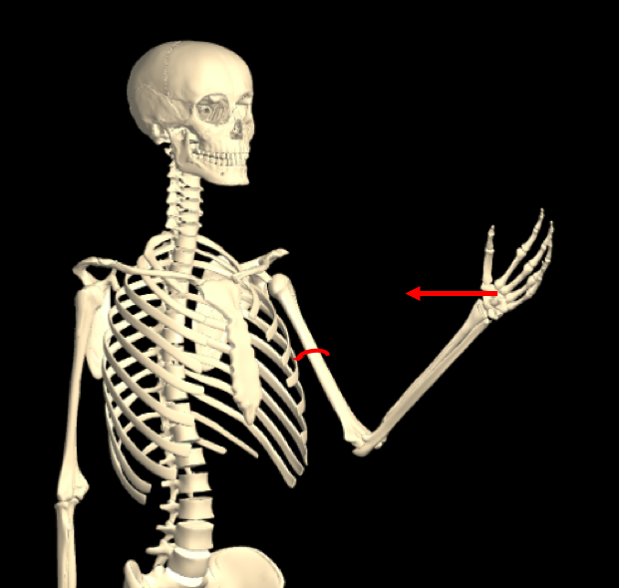

Background Info:

Arm wrestling may be a simple activity used by strong men to pass time and imply superiority, but there is more involved than one may notice at a first glance. An arm wrestling matchup is a system of forces, torques, and tensions. It can be simulated with a model of an arm wrestling match, which can be used to evaluate different methods of increasing the chance of winning.

There are several known factors that can help vanquish an opponent. These include: keeping the elbow close to the body, pulling the hand towards the shoulder, bending the wrist inwards, and using the body’s side pressure to engage in a press. Although these are simple bar tricks, there are physical properties at play that enable these techniques to tip the odds in one participant’s favor. Different arm configurations may provide additional leverage, allow a person to exert more force, or to allow force exerted to be applied more directly to the opponent.

Hypothesis/Model:

The maximum force exerted can be increased by reducing the angle of the elbow and reducing the length of the forearm.

This model is a simplification of the arm wrestling system. For example, it assumes that the only force applied on the arm is torque from the force of the pectoral muscle. It also assumes that the motion of the arm is in a single axis, and only occurs in a rotational form. However, other muscles can contribute to the movement of the arm, and the arm moves in multiple axes.

Free-body Diagrams:

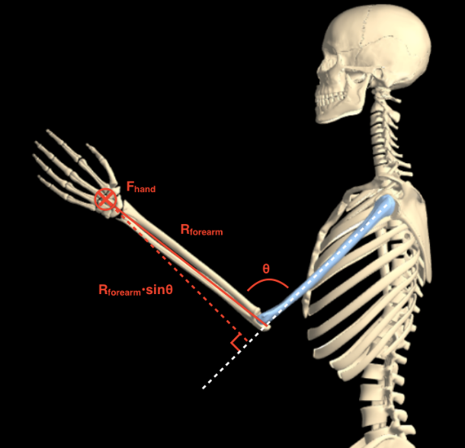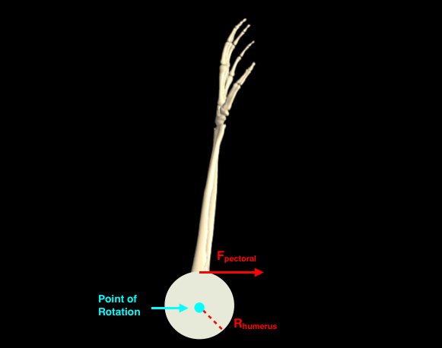

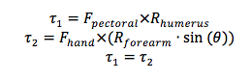

Possible Experiments:

The main experiment to test the effect of the angle in the elbow and the length of the forearm on success in arm wrestling is to use a force meter to measure the maximum exerted force when the two variables are modulated independently. For example, for one set of trials, the forearm will be kept at a constant length as the angle of the elbow is adjusted between trials. In each trial, the subject will assume the arm wrestling position with a string in his/her hand attached to a force meter, and pull as hard as possible. This will measure the maximum force the subject is able to exert with the given arm position. The angle will be modified to measure the maximum forces over a range of angles. The following will be performed isolating the length of the forearm by keeping the elbow constant at a right angle, and changing the length of the forearm over trials. This experiment can be performed on a few subjects, with possibly 10-20 trials each (5-10 for each independent variable). Statistical analysis will be performed by using INNOVA to create a regression model.

This experiment can also be performed using a weighted cable pulley machine, in which the weight connected to the pulley is variable. Using this machine, the maximum force can be determined by observing the maximum weight the subject can move. The subject will pull the cable with his/her arm in the arm wrestling position, with different trials having different arm position as described previously.

Required Equipment:

Spring Force meter (able to measure large magnitude of force)

Sources

http://www.iworx.com/documents/LabExercises/EMG-ArmWrestling.pdf